Normal Distributions
Normal distributions are defined by their mean () and their standard deviations ().

Generally we are given a value 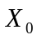, and are asked to calculate 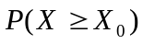 or alternatively 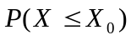, where X is a normally distributed random variable.

There exists a value 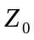 such that = 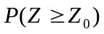, where Z is a random variable distributed according to the Standard Normal Distribution.

For a given , can be easily determined from the Statistical tables (Murdoch Barnes Table 3, page 13)

can be calculated by using the standardisation formula

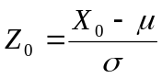

Example 1
X is intelligence quotient , a normally distributed random variable
mean () =100 standard deviations () =15

We are asked to find 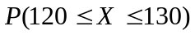

1) = 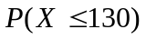-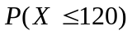

With 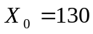 then 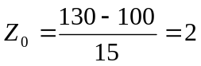

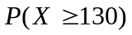 = 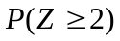 = 0.02275
Therefore = 0.97725
Complement Rule
= 1-

With 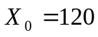 then 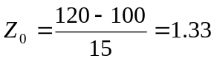
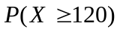 = 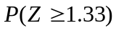 = 0.0912

Therefore = 0.9087

= -
=0.97725 -0.9807
= 0.0684

Example 2
X is intelligence quotient , a normally distributed random variable
mean () =100 standard deviations () =15

We are asked to find such that 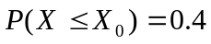

is going to be a negative value ( less than )
Symmetry Rule
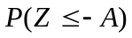 = 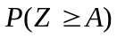 for any given value A

Find such that 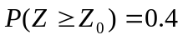
From table = 0.255 (approx)
Therefore we need the value = -0.255

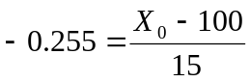

Solving for we get = 96.17

